Name : Vivek Singh
RegNumber : 230905408
Roll Number: A50

Lab 3: Bootstrap

Q1) Design the student bio-data form using button, label, textbox, radio button, table and checkbox.
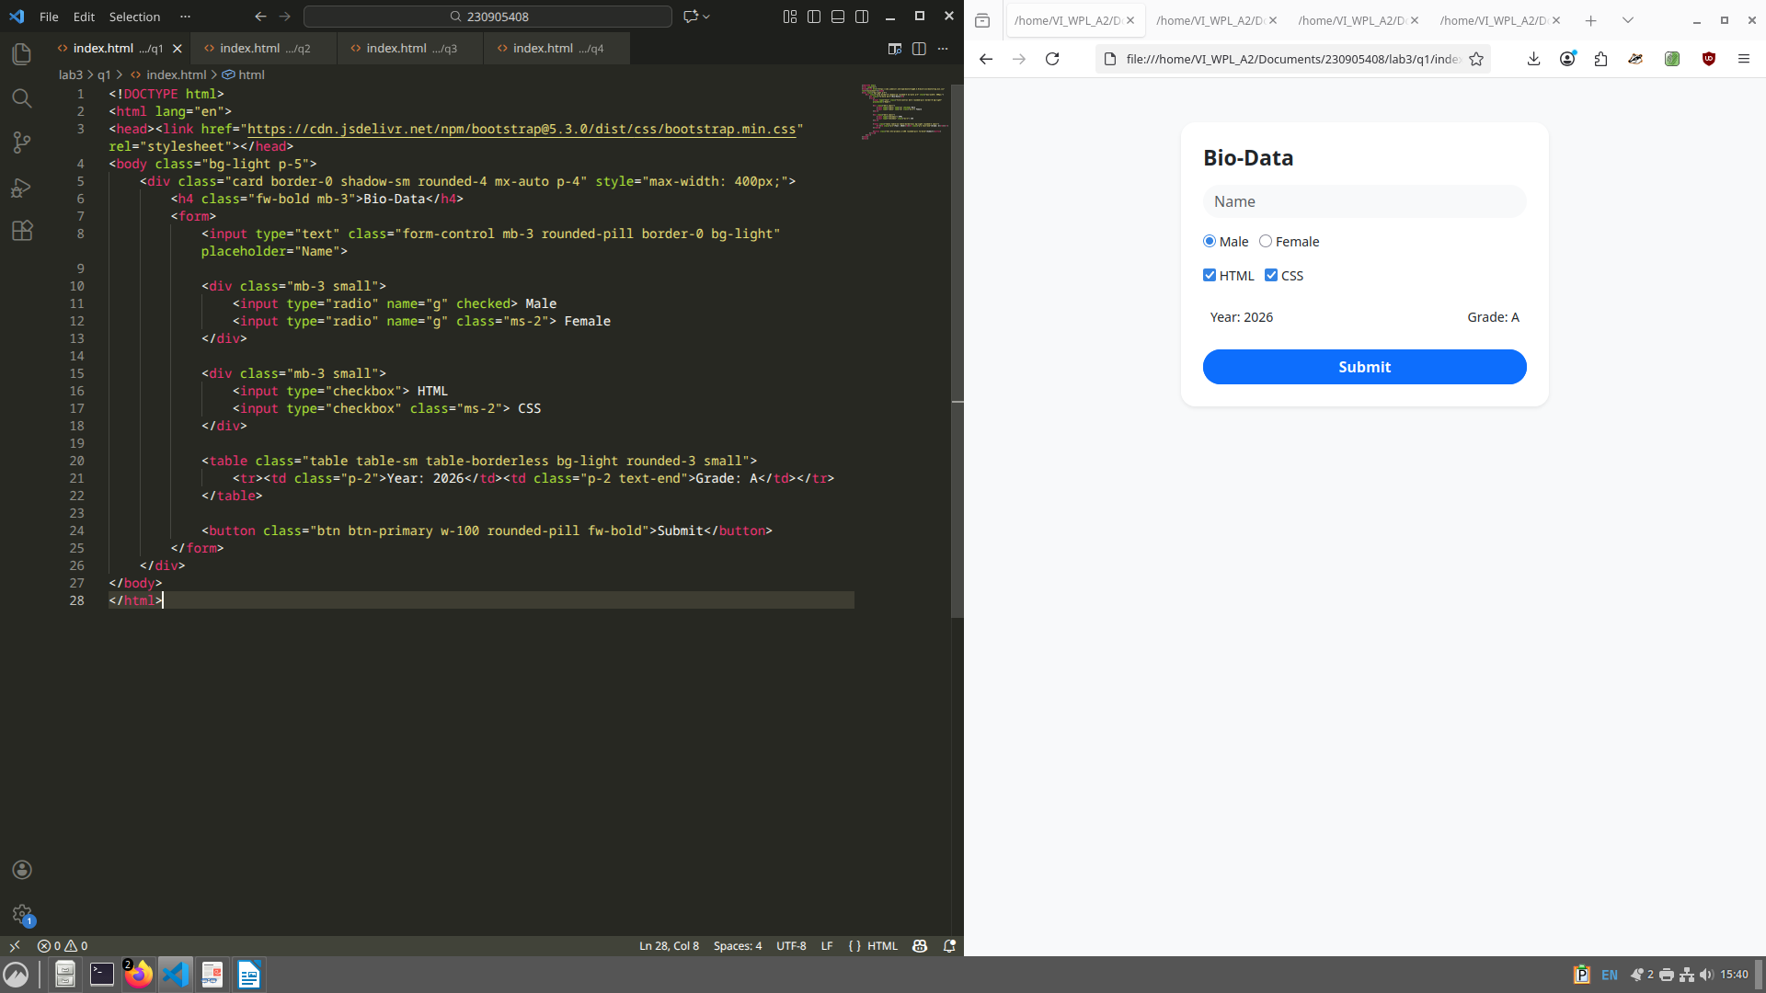

Q2) Design a web page which shows the database-oriented CRUD operation. Consider Employee data.
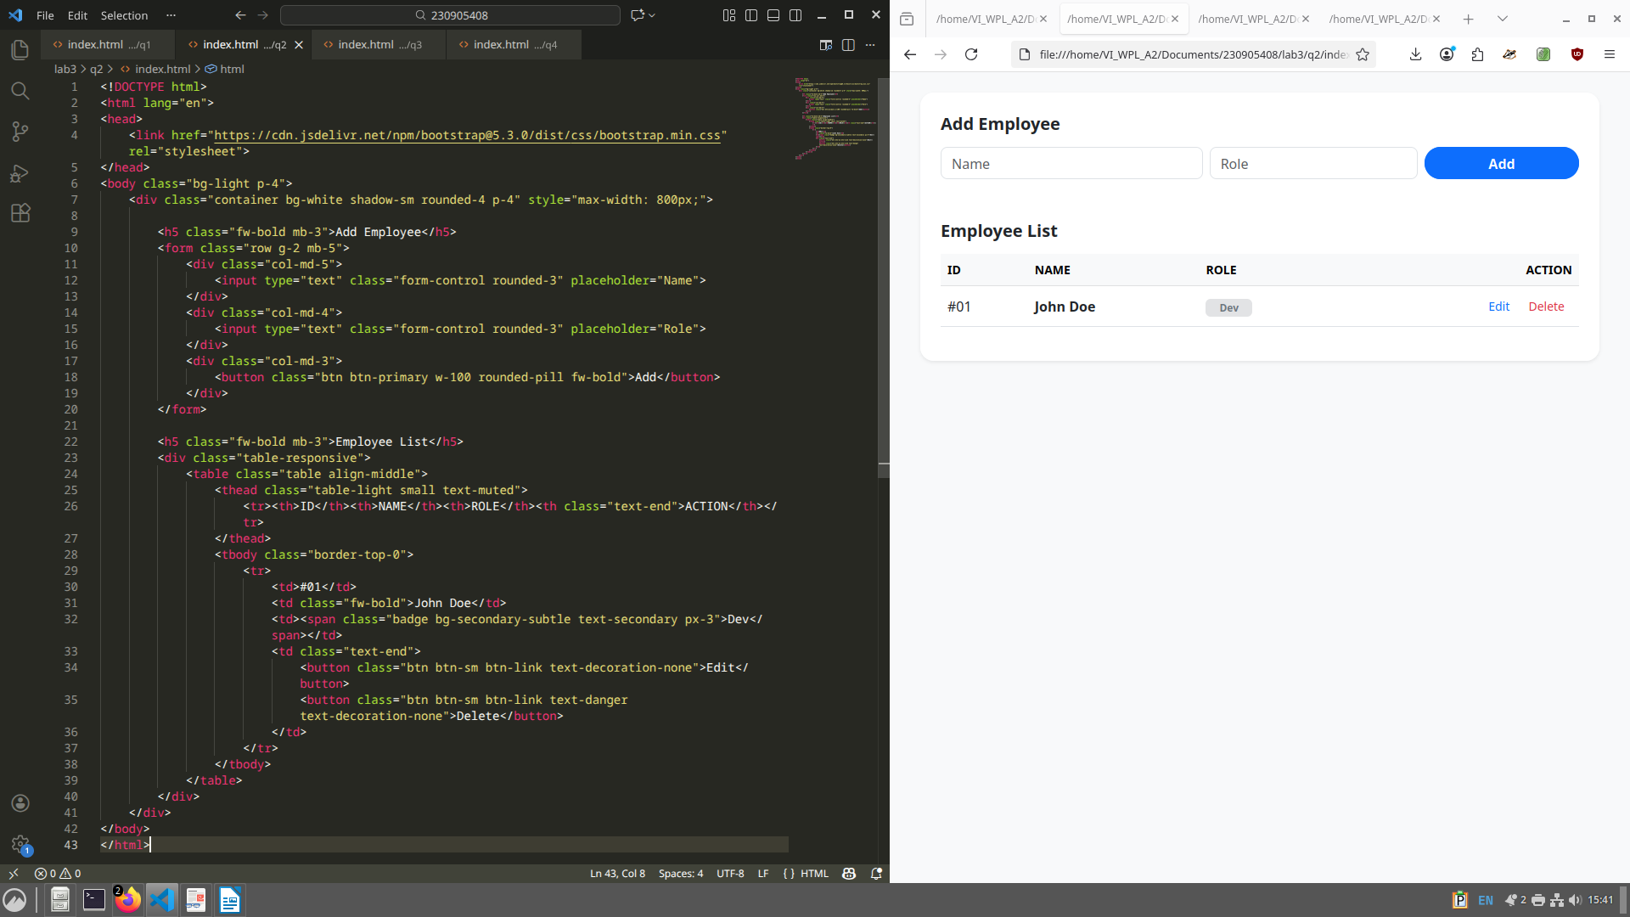

Q3) Create a web page using bootstrap as mentioned. Divide the page into 2 parts top and bottom, then divide the bottom into 3 parts and design each top and bottom part using different input groups, input, badges, buttons and button groups. Make the design more attractive.

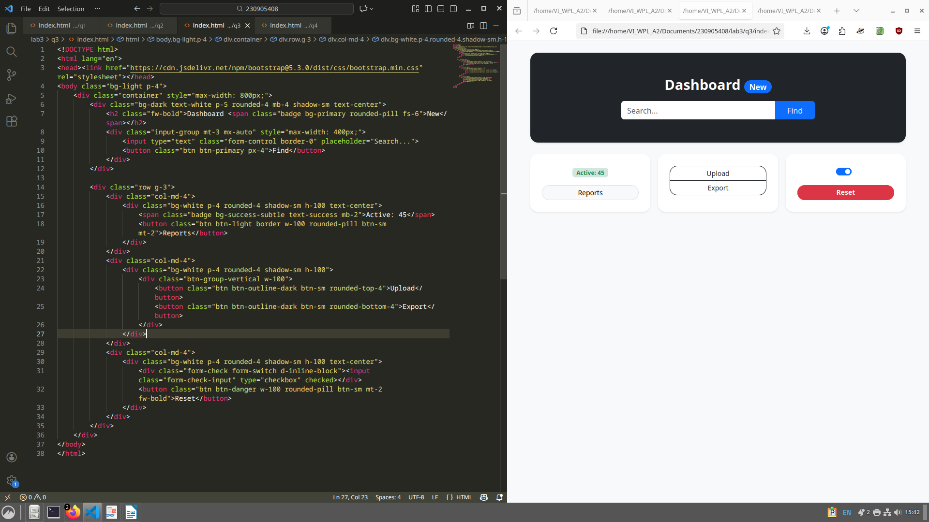

Q4) Design your class timetable using bootstrap table and carousel.
